S.JOE MATHEW

ESSENTIAL PROJECT 1

## Module 1A (LAB 1): Creating a Zero Trust Environment

**Summary:** In this module, we created a zero day trust environment by creating zones, applying security policies and after that we tested it. We created 3 zones inside, outside & DMZ for different purposes. We also created NAT Policies for packets. After committing all the changes, we tested it by visiting a webpage and we can see all the traffic in Firewall Logs.

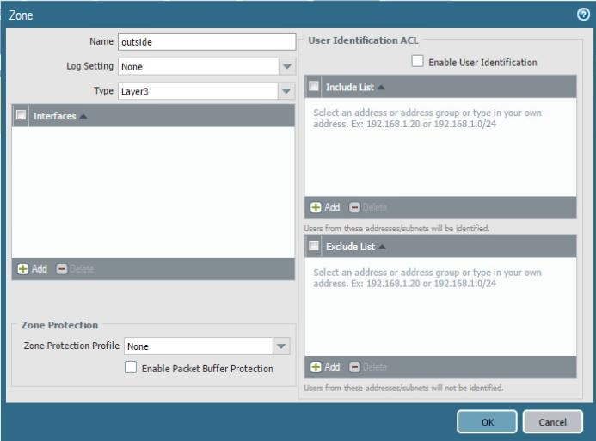

* Creating Zones

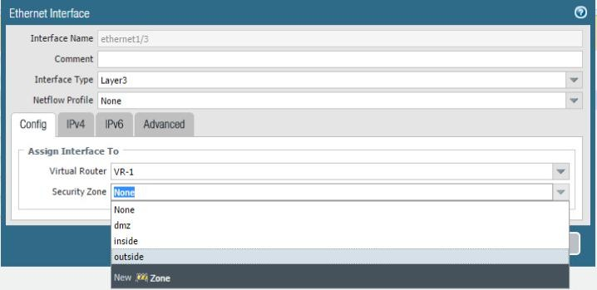

* Configuring Ethernet Interfaces

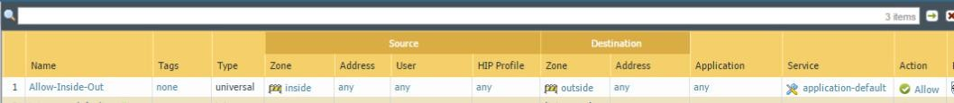

* Creation of Rules

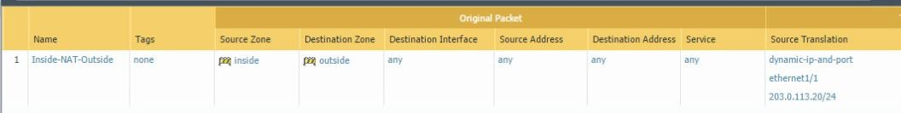

* NAT Configurations

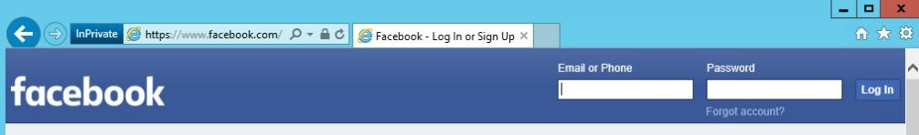

* Testing Process (Visiting a Webpage)

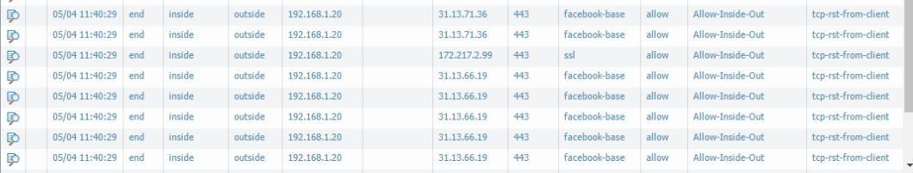

* We can see detailed information about traffic in Logs.

## Module 1B (LAB 2): Configuring Authentication

**Summary:** In this module, we implemented a captive portal gateway for accessing web services in Palo Alto Firewall. We also created local user authentication for security and monitoring. We also analyzed logs of the user.

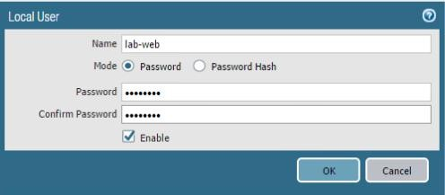

* Creating a Local User Account

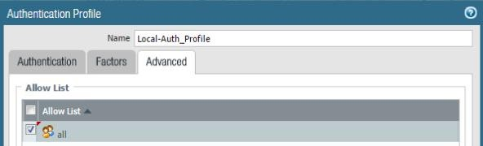

* Creating an authentication profile

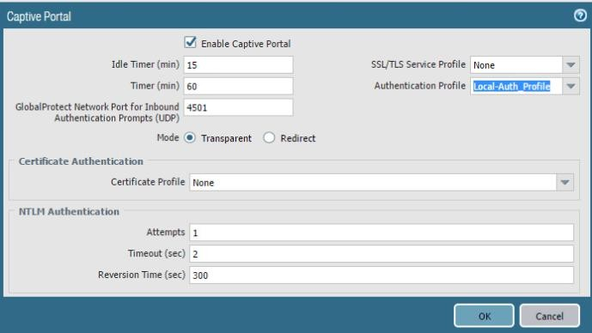

* Captive Portal Configurations

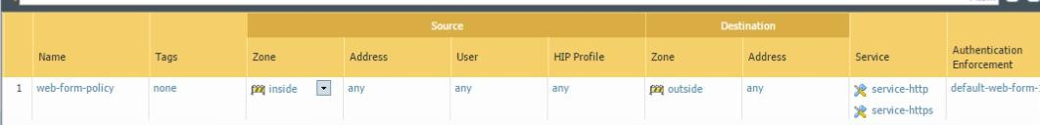

* Firewall Rules Configurations

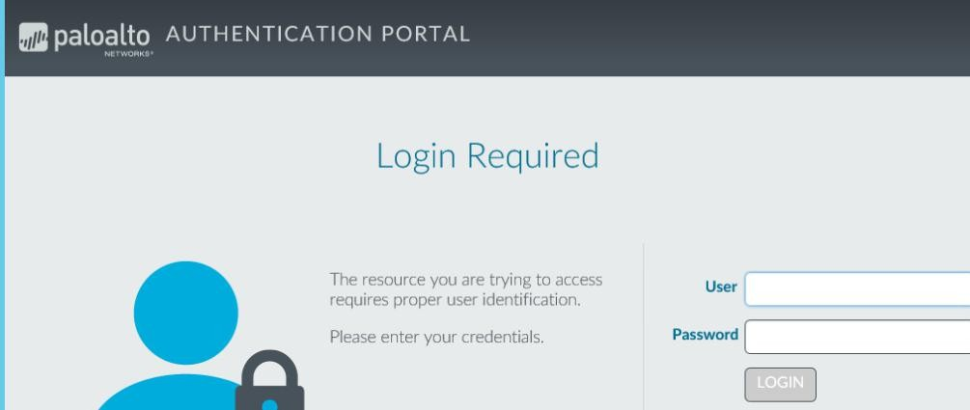

* Our Captive Portal asking for User Information

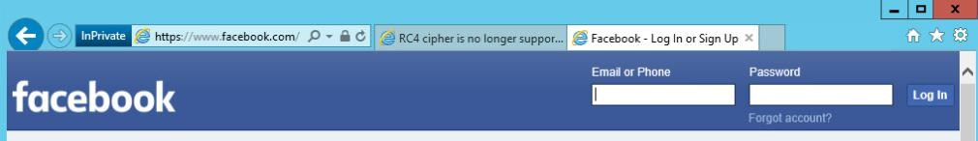

* After Successful login user can access websites

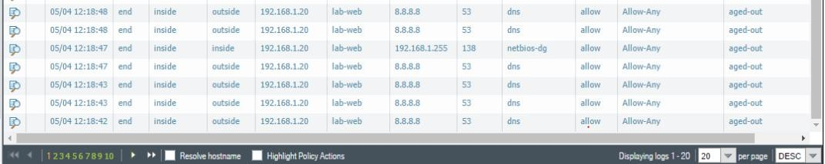

* We can monitor user’s activity in the logs

## Module 2A (LAB 3): Using 2 Factor Authentication to secure the Firewall

**Summary:** In this module, we enabled 2 Factor authentication for Palo Alto Firewall using a digital certificate.

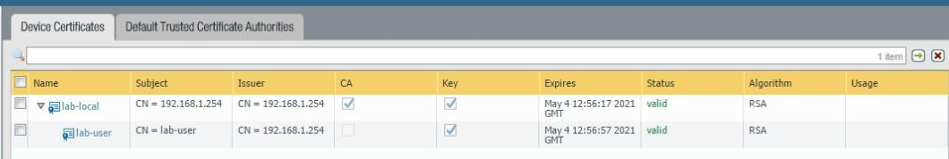

* Creating User account for digital certificate.

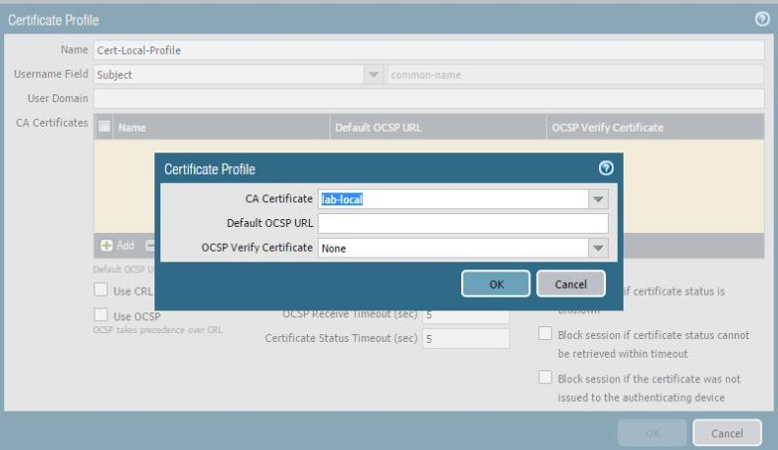

* Creating Certificate Profile

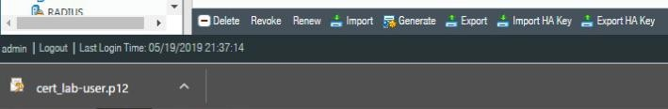

* Downloading Certificate for the User

## Module 2B (LAB 4): Allowing only Trusted Applications

**Summary:** In this module, we configured our firewall to allow traffic from and to selected apps. First we made an application group and added the websites to it. Then we configured security policy rule for the same. Then we tested it and analyzed the results.

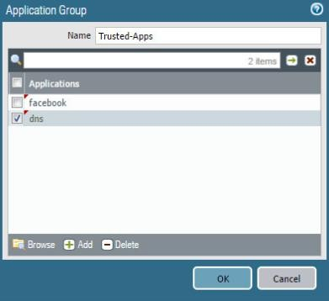

* Application Group Configurations

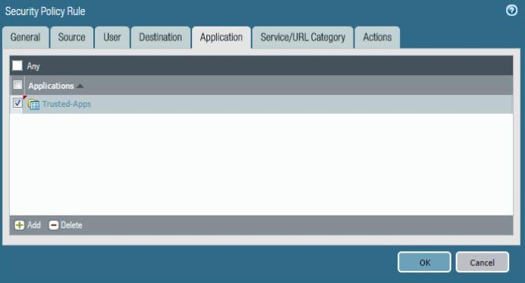

* Security Policy Rule Configurations

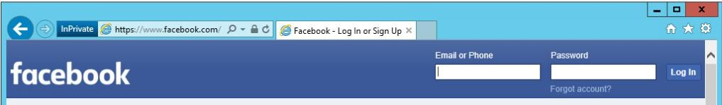

* Testing the rules and configurations

## Module 3A (LAB 5): Managing Certificates

**Summary:** In this module, we generated a digital certificate for inbound management traffic. After that we exported tested and verified it.

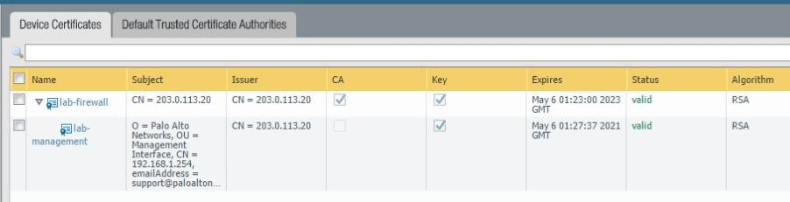

* Certificate Generation

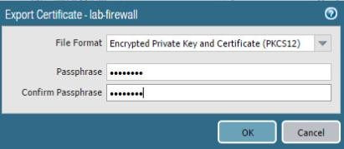

* Exporting Certificate

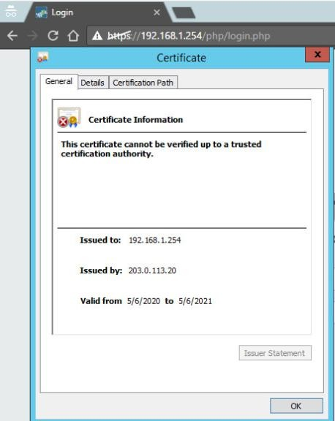

* Testing it and we can see that it is not verified.

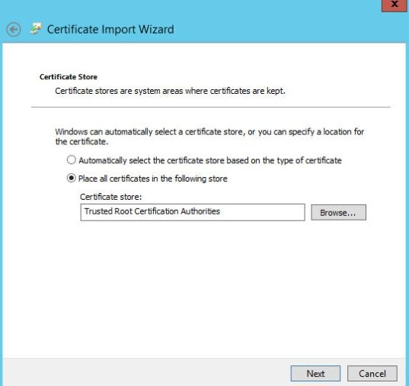

* After downloading it locally, we imported it in the to certificates.msc utility.

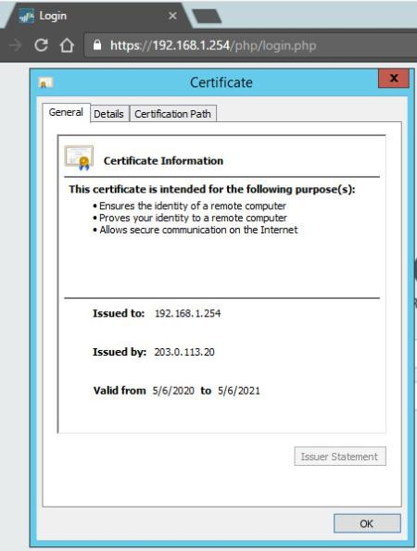

* Now if we try to test it, it is verified now.

## Module 3B (LAB 6 & 7): Decrypting SSH Traffic

**Summary:** In this module, we decrypted some SSH Packets. First, we created a Policy for decryption from inside zone to DMZ. Then we generated SSH Traffic towards DMZ. After that we decrypted it using the same policy.



* Creation of the Policy

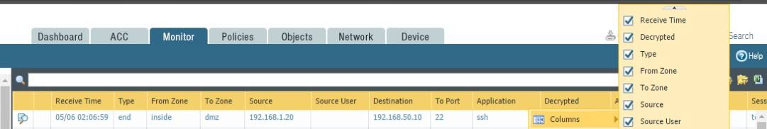

* Decrypting traffic in logs

# Project Introduction:

In this project, you will configure the firewall for a zero - trust environment.

Objectives:

* 1. Create zones and associate the zones to interfaces
  2. Create a Security Policy Rule
  3. Create a NAT Policy.

**Screenshot:**



* Creating Zones



* Configuring Ethernet Interfaces



* Creation of Rules



* NAT Configurations



* Testing (Visiting Facebook)



* We can see detailed information about traffic in Logs.